

SOFTWARE ENGINEERING B9IS118

LECTURER YUSUF AYTAS

Group members:

Arivoli Ravichandran – student no:

Sharon Farrell - student no: 10581193

Sugeeth SG – student no:

Assignment Overview 3

Business Requirements 3

Agile Epics and User Stories 3

Context Model 3

Entity relationships 3

Class Diagrams 3

Sequence Diagrams 3

Testing 3

Conclusion 4

Figure 1 Online Booking System login page

Figure 2 User setup form

# Assignment Overview

We have been instructed by a Family Entertainment Center to develop an online booking system for their center. The center has several different activities as well as a café. The activities include trampolining, inflatables, soft play and parties. The system will have several capabilities and functions including the following.

1. Customers' ability to set up an account with a login and password.

On the website the user will have an option to fill in a risk acknowledgement form, where they will be asked to enter an email address or start a new form. On setting up an account the user is required to add their email address and create a password, enter their name, address and phone number. They will then. be asked to add their child or children with child’s name and date of birth.

On the website site the user Once the user has the account set up, they will be able to login using their email address and password to then search an activity online and view the date and time they want.

The different activities include trampolining, inflatables, soft-play and parties. These activities are booked on the hour and half - hour for the duration of 1 or 2 hours, the user should have the functionality of booking more than one activity on a selected date or time.

The user will be directed to a payment page when they have confirmed their order, where they will enter their payment method and details.

Once the payment is approved the user will get a confirmation email with the sale id and activity Id. This will give the user the option to give invited guests the activity ID that can be used to add their child to the activity. This is especially useful for parties as all the children entering the facility must have a risk form completed by a parent or guardian

The system must be capable of cross-referencing names and addresses to avoid duplication

1. The main administrator should have the ability to log into the system and update the activities. They will be able to change the number of time slots that are available on a given date, the capacity of each activity and the cost of these activities. They will also be able to add staff members and their roles to the system, which will create a database for the employees and their working hours. They will be able to run daily sales reports and activity reports and track the payments received both in-house and online.
2. The System will double up as a time clock for staff to track their hours worked.
3. On the payment gateway the administrator will be able to access payment reports daily to reconcile the payments received.
4. When an online booking is completed an email alert will be sent to the company email alerting them of the booking. Admin can check the details of the bookings to make sure that the booking is in order. The information in the email will be the sale and activity ID, the payment made, payment id, number of participants, date and time of the booking and activities. If a party is booked Terms and conditions will be sent to the user.

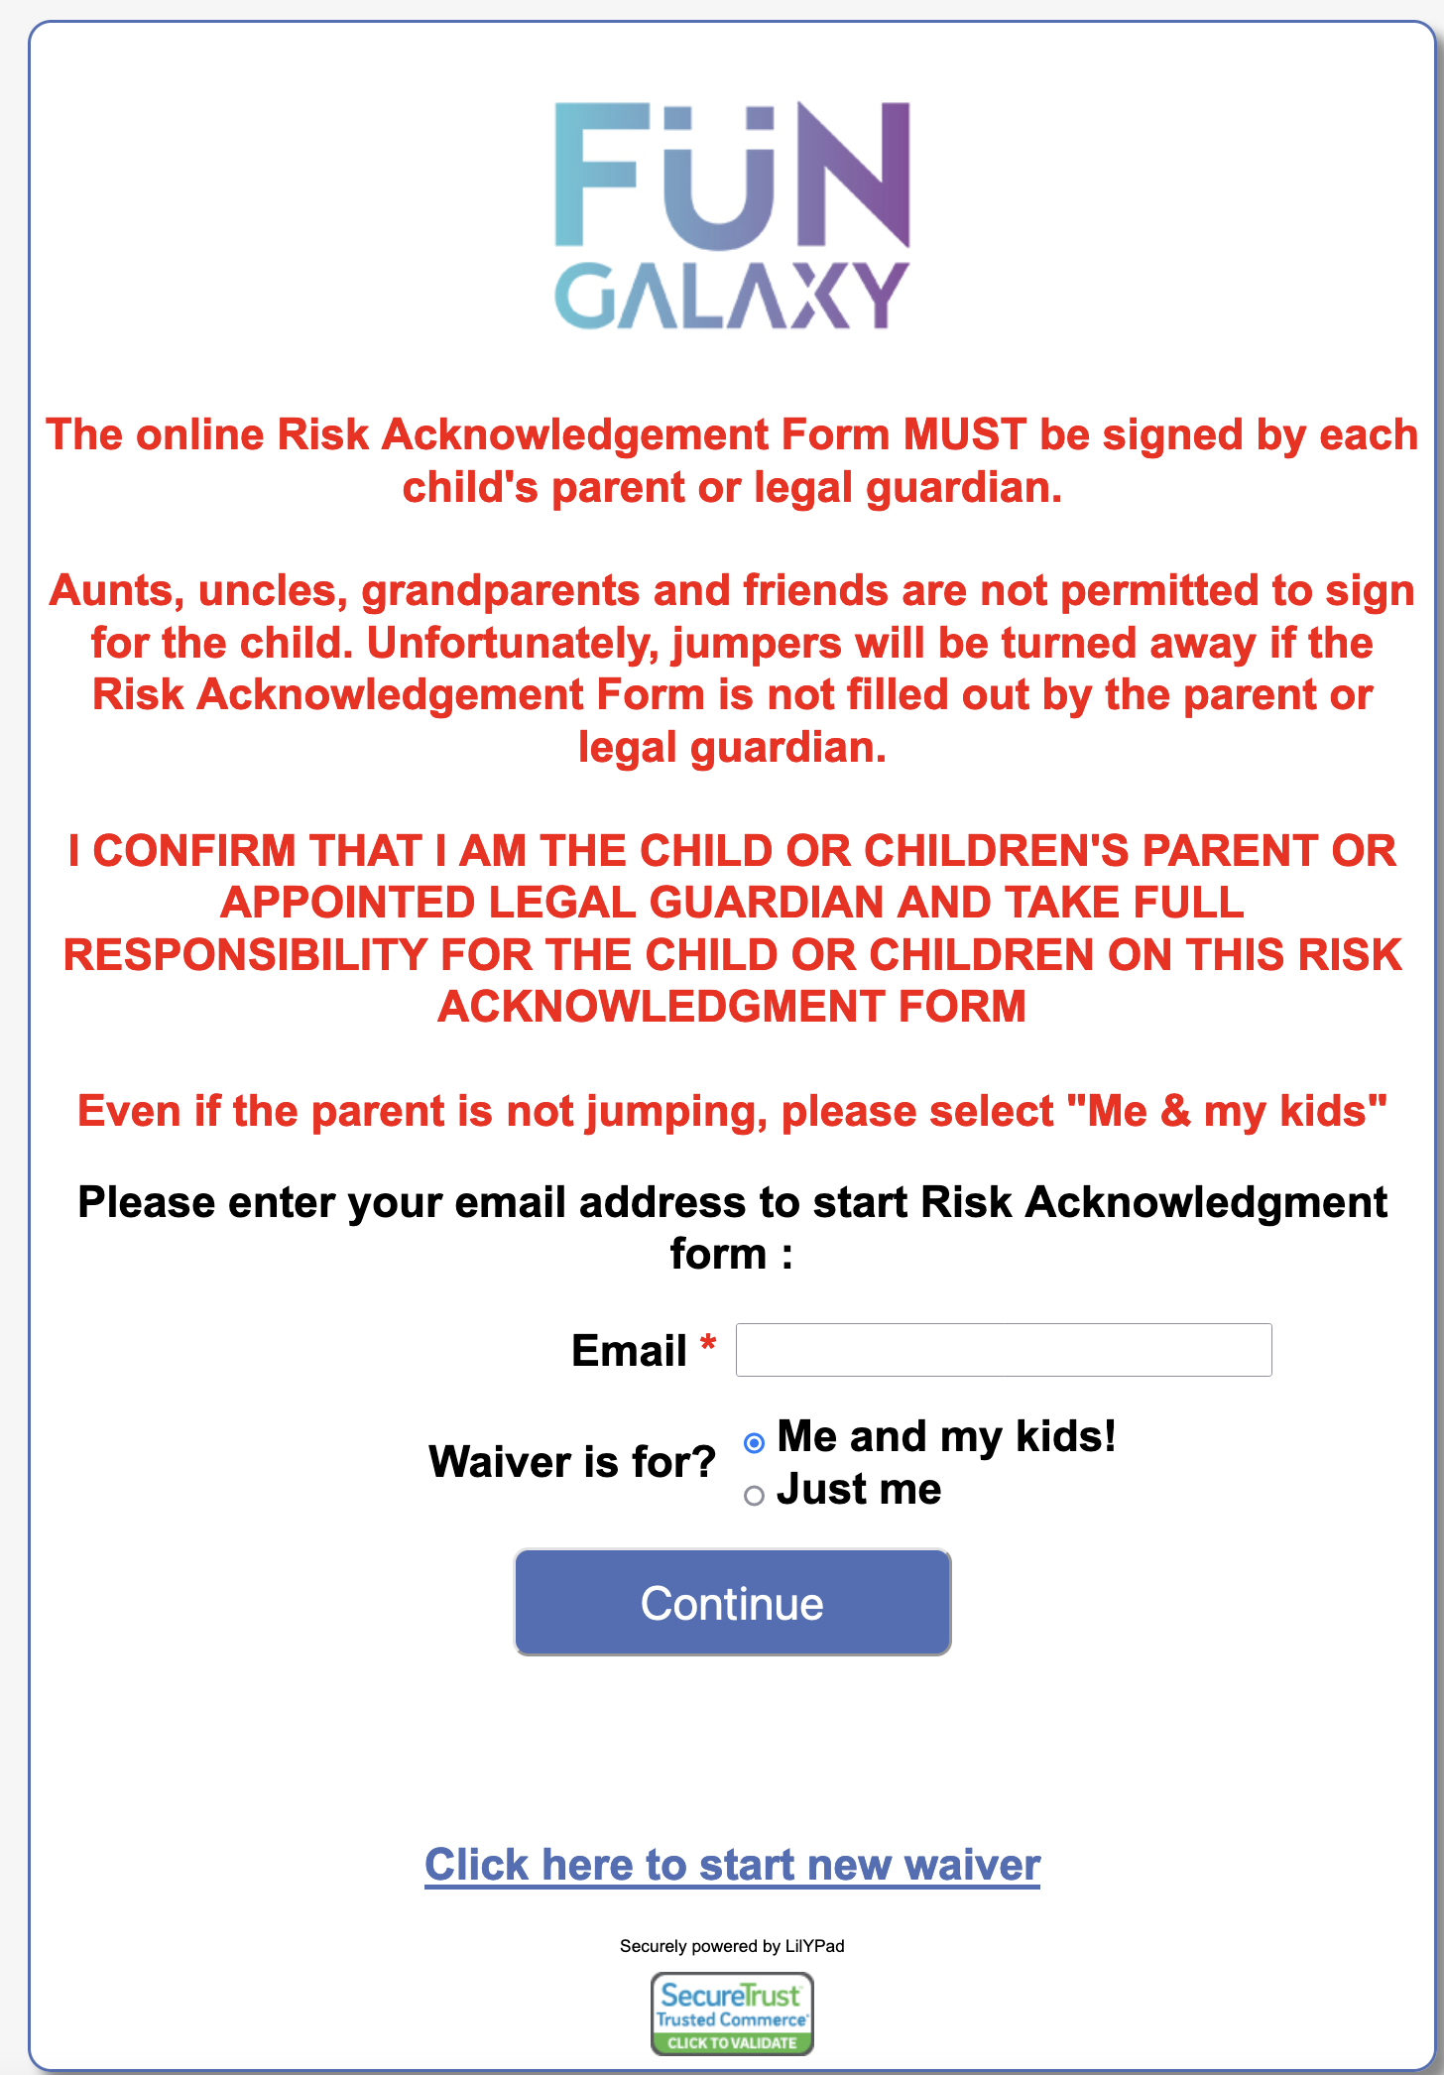

# Online login screen

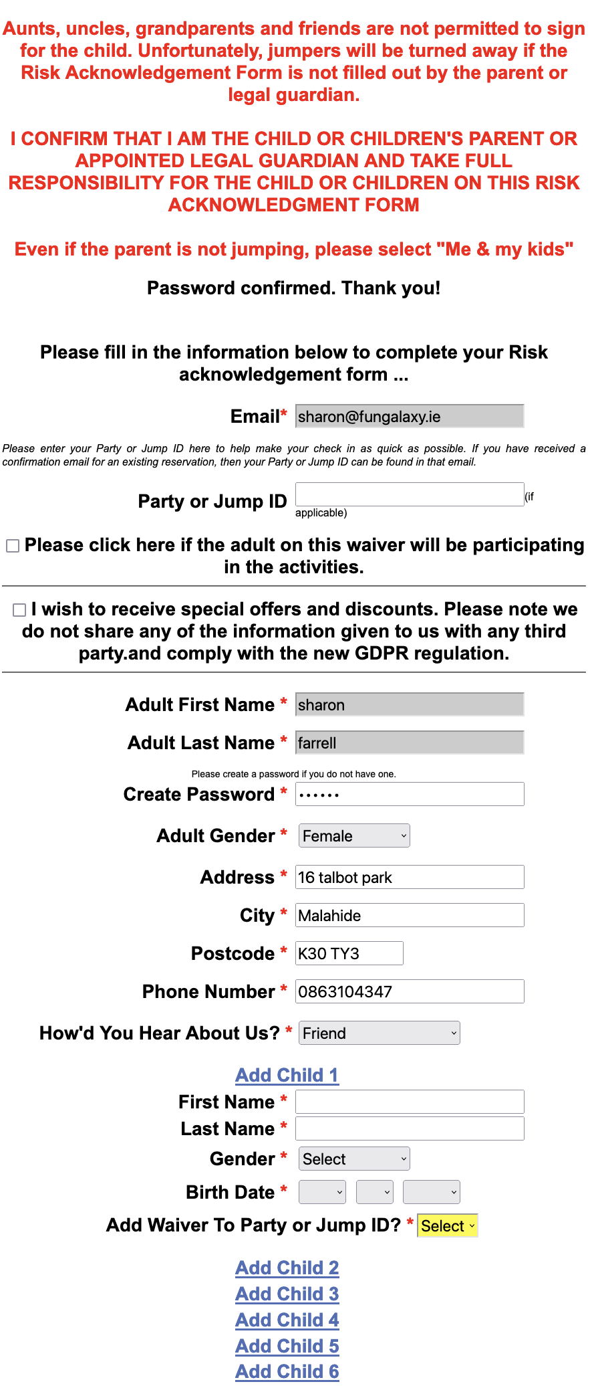

# Risk Form Details

# Business Requirements

# Agile Epics and User Stories

# Context Model

Entity relationships

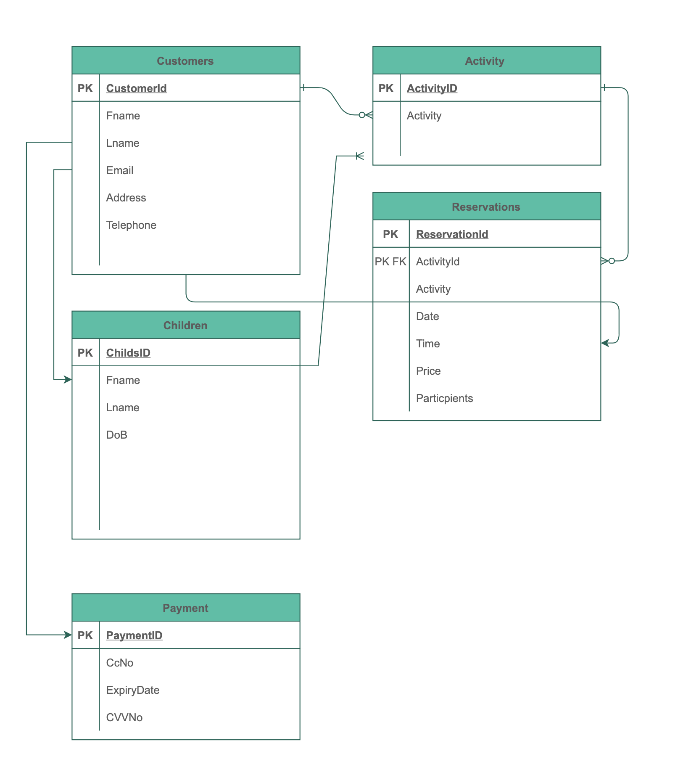

# Figure 3 Entity Relationship Diagram

Entity Relationship Diagrams (ERD) are a way for us to demonstrate the flow of the booking system and decide what relationships we need for the flow of the booking to work. It shows whether we have 1 to 1, 1 to many, many to many as in one user can have many children, one user can make many reservations, one user can make one payment at a time, one reservation can have many activities. It also shows what the Primary key will be for the entities. The ERD visualizes the relationship between entities such as people, things or concepts in a database. When we define the entities, their attributes and the relationship between them we can see the logical structure of the database. The ERD helps the software engineers document the database and see where the relationships lie. It will also help us troubleshoot protentional problems and identify inefficiencies in the design of the database.[]

The entity relationship diagram above in Figure 3 gives the details of the relationship between the functions of the system we are designing. The diagrams show the flow of the system. Customers enter the website where they can see the activities. The idea is for the customer to be able to view an activity and click “BOOK ONLINE” where they will be asked to enter their email address or set up a new account. When they enter their email address and password, they will have the option to choose an activity – Trampolining, Inflatables, Soft Play or Parties. When they choose an activity, they can then pick a date where the system will show them the times and capacity available. The user will choose the date and pick a time, they will then pick the number of participants and add the child’s or children’s names to activities, the user will be asked if they would like to add another activity if not they will confirm the reservation and then proceed to the payment gateway.

In the diagram above it shows that the user can add 1 or many activities, 1 or many children to their profile, 1 payment to the booking. They view the activity and choose which activities they want to add pick the date and time and then the number of participants, they confirm the reservation and proceed to payment where they will be asked what card type and to enter the card details including their name, the 16 digits on the card, the expiry date and the CVV number, they will then get a confirmation of the payment or decline.

Once the booking is completed the user will receive a confirmation email with the activity and sale ID.

Admin has the ability to update the system when and where it needs to. They need to be able to change the times, dates, pricing of the activities and be able to block off a slot if there is a group booking. They will also have access to make notes on a customer profile, alter their details and delete if necessary. They will also be able to run reports on the activities or sales, view the Calander to see what bookings are made, edit bookings.

# Class Diagrams

# Sequence Diagrams

# Testing

# Conclusion